Subject: MAE101
Number of question: 50

QN=1 | Which the following propositions is FALSE:
a. | If 1+1=3 or 1+1=2, then 2+2=4 and 2+2=1
b. | If 1<0, then 1 = 0
c. | 1+1=3 if and only if 1+2=0
d. | If 2+1=3, then 4=5-1
e.
ANSWER: | A
MARK: | 1
UNIT: | 1
LO: | 0
MIX CHOICES: | Yes

QN= 2 | Let P is the statement “Lucy has an invention”.  Let Q is the statement “Lucy gets a prize”.  Which of the following English statements can be used for "P → Q"?  (i) She will get a prize if she has an invention  (ii) A prize is necessary for having an invention
a. | Both (i) and (ii)
b. | (ii) only
c. | (i) only
d. | None of the others
e.
ANSWER: | A
MARK: | 1
UNIT: | 1
LO: | 0
MIX CHOICES: | Yes

QN=3 | Study the following computer code segment:  x:= 5  If (1+1=0) OR (2+2=4) then x:=x+1  If (1+1=2) AND (1+2=3) then x:=2x+1  What are values of x after the codes execute?
a. | 13
b. | 5
c. | 11
d. | 6
e.
ANSWER: | A
MARK: | 1
UNIT: | 1
LO: | 0
MIX CHOICES: | Yes

QN=4 | Premise: Everyone, who is over 30, can read newspaper.  Premise: Mr. Bean cannot read newspaper.  Premise: Mrs. Bean is 26 years old.  Conclusion 1: he is not over 30.  Conclusion 2: she cannot read newspaper.
a. | The conclusion 1 is logical and the conclusion 2 is not.
b. | Both conclusions are illogical.
c. | The conclusion 2 is logical and the conclusion 1 is not.
d. | Both conclusions are logical.
e.
ANSWER: | A
MARK: | 1
UNIT: | 1
LO: | 0
MIX CHOICES: | Yes

QN=5 | Study the following arguments:  (i) All parrots like fruit. My pet bird is not a parrot. Therefore, my pet bird does not like fruit.  (ii) If Mai is smart, then she knows French. But she doesn't know French. So, she is not smart.  (i) is ... and (ii) is ...
a. | illogical, logical
b. | illogical, illogical
c. | logical, illogical
d. | logical, logical
e.
ANSWER: | A
MARK: | 1
UNIT: | 1
LO: | 0
MIX CHOICES: | Yes

QN=6 | How many rows appear in a truth table for the proposition  (q → ¬p) ∨ (¬p → ¬q) ?
a. | 4
b. | 2
c. | 16
d. | 8
e.
ANSWER: | A
MARK: | 1
UNIT: | 1
LO: | 0
MIX CHOICES: | Yes

QN=7 | If f: Z → Z; f(x) = 2x+3.  Which of the following statements is true?  (i) f is one-to-one  (ii) f is onto
a. | (i) only
b. | (ii) only
c. | Both (i) and (ii)
d. | None of the others
e.
ANSWER: | A
MARK: | 1
UNIT: | 1
LO: | 0
MIX CHOICES: | Yes

QN=8 | Let f be floor function and g be ceiling function.  Which of the following is true ?
a. | g(-4.5) = - 4
b. | g(5) = 6
c. | f(-6.1) = - 6
d. | f(9.9) = 10
e. | None of the others
ANSWER: | A
MARK: | 1
UNIT: | 1
LO: | 0
MIX CHOICES: | Yes

QN=9 | Let U = {0,1,2,3,4,5,6,7,8,9}.  Given the subsets A = {1,2,3,4,8}, B = {1,5,6,7,8}. The bit string representing the subset A - B is
a. | 00 1110 0000
b. | 00 1110 0010
c. | 01 1110 0110
d. | None of the others
e.
ANSWER: | A
MARK: | 1
UNIT: | 1
LO: | 0
MIX CHOICES: | Yes

QN=10 | Given A={0,Ø,1}. Find the cardinality of P(AxA).
a. | 512
b. | 9
c. | 81
d. | 8
e. | None of the others
ANSWER: | A
MARK: | 1
UNIT: | 1
LO: | 0
MIX CHOICES: | Yes

QN=11 | [file: t11.gif]
a. | 6
b. | 5
c. | 11
d. | 16
e. | None of the others
ANSWER: | A
MARK: | 1
UNIT: | 1
LO: | 0
MIX CHOICES: | Yes

QN=12 | [file: t12.gif]  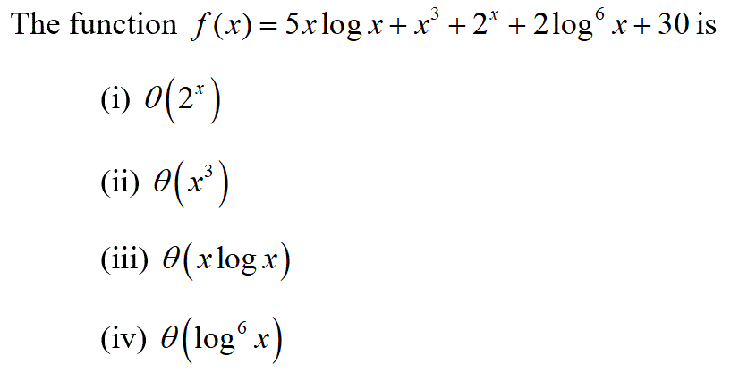
a. | (i)
b. | (ii)
c. | (iii)
d. | (iv)
e.
ANSWER: | A
MARK: | 1
UNIT: | 1
LO: | 0
MIX CHOICES: | yes

QN=13 | Encrypt the message HE by translating the letters into numbers ( the character A is translated to 0), applying the encryption function f (p) = (p + 3) mod 26, and then translating the numbers back into letters. Encrypted form:
a. | KH
b. | QH
c. | TK
d. | HQ
e. | None of the others
ANSWER: | A
MARK: | 1
UNIT: | 1
LO: | 0
MIX CHOICES: | Yes

QN=14 | [file: t14.gif]  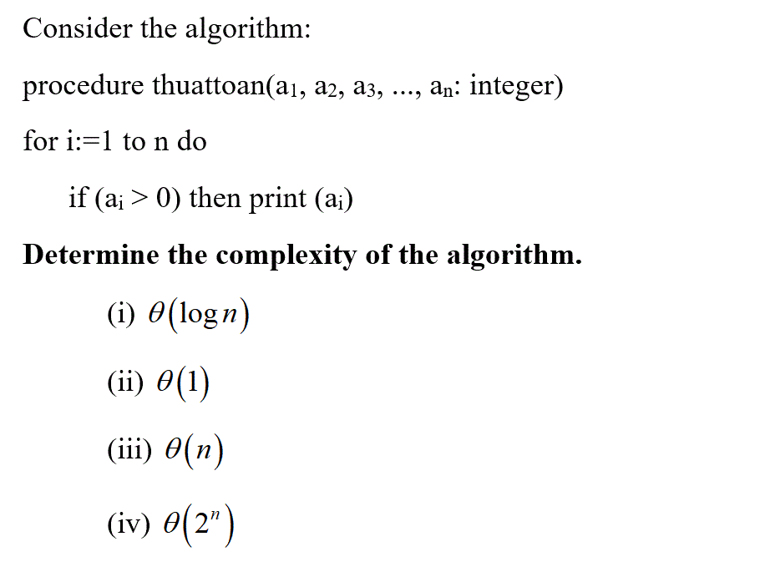
a. | (iii)
b. | (ii)
c. | (i)
d. | (iv)
e.
ANSWER: | A
MARK: | 1
UNIT: | 1
LO: | 0
MIX CHOICES: | Yes

QN=15 | [file: t15.gif]  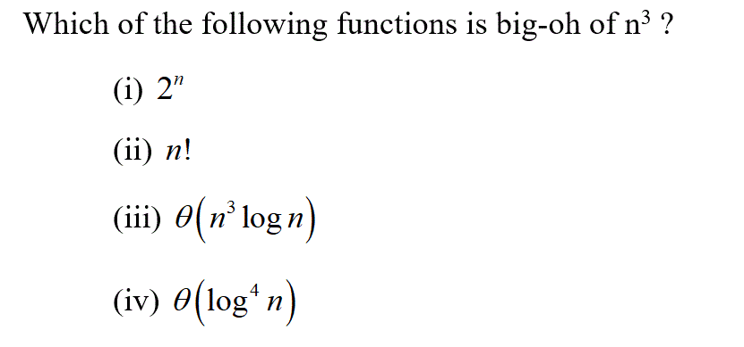
a. | (iv)
b. | (i)
c. | (ii)
d. | (iii)
e. | None of the others
ANSWER: | A
MARK: | 1
UNIT: | 1
LO: | 0
MIX CHOICES: | Yes

QN=16 | Let a = -17 div 5 and b = -17 mod 5. Find a + b
a. | -1
b. | 0
c. | 1
d. | 7
e. | None of the others
ANSWER: | A
MARK: | 1
UNIT: | 1
LO: | 0
MIX CHOICES: | Yes

QN=17 | Which of the following statements is false?
a. | 0 ∈ Ø
b. | Ø ⊂ {0}
c. | {x} ⊆ {x}
d. | |{ Ø }|=1
e.
ANSWER: | A
MARK: | 1
UNIT: | 1
LO: | 0
MIX CHOICES: | Yes

QN=18 | Suppose a mod 3 = 2 and b mod 6 = 4, find ab mod 3
a. | 2
b. | 8
c. | 0
d. | -1
e. | None of the others
ANSWER: | A
MARK: | 1
UNIT: | 1
LO: | 0
MIX CHOICES: | Yes

QN=19 | Which memory locations are assigned by the hashing function h(k) = k mod 101 to the records of insurance company customers with the Social Security Number 104578690
a. | 58
b. | 81
c. | 90
d. | 10
e. | None of the others
ANSWER: | A
MARK: | 1
UNIT: | 1
LO: | 0
MIX CHOICES: | Yes

QN=20 | Let S be the set defined recursively by: 5 is in S, and if x is an element of S then x+5 is an element of S. What is S?
a. | S={5,10,15,20,…}
b. | S={0,5,10,15,20,…}
c. | S={0,1,2,3,4,…}
d. | S={…,-10,-5,0,5,10 ,…}
e.
ANSWER: | A
MARK: | 1
UNIT: | 1
LO: | 0
MIX CHOICES: | Yes

QN=21 | [file: t21.gif]
a. | 36
b. | 48
c. | 108
d. | 12
e. | None of the others
ANSWER: | A
MARK: | 1
UNIT: | 1
LO: | 0
MIX CHOICES: | Yes

QN=22 | Consider the algorithm:  Procedure T(n: positive integer)  If n=1 then T(n) := 3  else T(n) := 3 + T(n-1)  What is the output if input is: n = 4
a. | 12
b. | 9
c. | 15
d. | None of the others
e.
ANSWER: | A
MARK: | 1
UNIT: | 1
LO: | 0
MIX CHOICES: | Yes

QN=23 | How many functions are there from the set {10, 11, 111} to the set {11, 01, 100, 111}?
a. | 64
b. | 81
c. | 24
d. | 0
e. | None of the others
ANSWER: | A
MARK: | 1
UNIT: | 1
LO: | 0
MIX CHOICES: | Yes

QN=24 | How many bit strings of length 10 begin with 100 or 01?
a. | 384
b. | 352
c. | 1024
d. | 512
e. | None of the others
ANSWER: | A
MARK: | 1
UNIT: | 1
LO: | 0
MIX CHOICES: | Yes

QN=25 | Let B be the set {a, b, c}. How many one-to-one functions are there from B to BxB
a. | 504
b. | 6
c. | 729
d. | None of the others
e.
ANSWER: | A
MARK: | 1
UNIT: | 1
LO: | 0
MIX CHOICES: | Yes

QN=26 | Study a simple graph having the degree sequence {6,5,5,4,4,4,3,3,2,2,2, 1,1}. If the graph has n edges, then n =
a. | 21
b. | 42
c. | 19
d. | 20
e. | None of the others
ANSWER: | A
MARK: | 1
UNIT: | 1
LO: | 0
MIX CHOICES: | Yes

QN=27 | [file: t27.gif]
a. | 12
b. | 8
c. | 24
d. | The graph does not have an Euler circuit
e.
ANSWER: | A
MARK: | 1
UNIT: | 1
LO: | 0
MIX CHOICES: | Yes

QN=28 | Suppose that f(n) = 2f(n/2) + 3 when n is an even positive integer, and f(1) = 5. Find f(16)
a. | 125
b. | 61
c. | 29
d. | 253
e. | None of the others
ANSWER: | A
MARK: | 1
UNIT: | 1
LO: | 0
MIX CHOICES: | Yes

QN=29 | Determine whether each of these sequences is graphic  - 5, 4, 3, 2, 2, 0  - 6, 5, 4, 3, 2, 1
a. | (i) only
b. | (ii) only
c. | Both (i) and (ii)
d. | None of the others
e.
ANSWER: | A
MARK: | 1
UNIT: | 1
LO: | 0
MIX CHOICES: | Yes

QN=30 | [file: t30.gif]  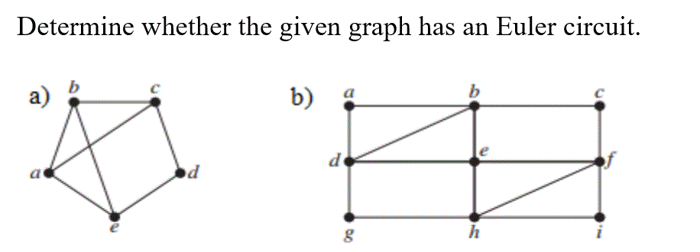
a. | b) only
b. | a) only
c. | Both a) and b)
d. | None of the others
e.
ANSWER: | A
MARK: | 1
UNIT: | 1
LO: | 0
MIX CHOICES: | Yes

QN=31 | [file: t31.gif]  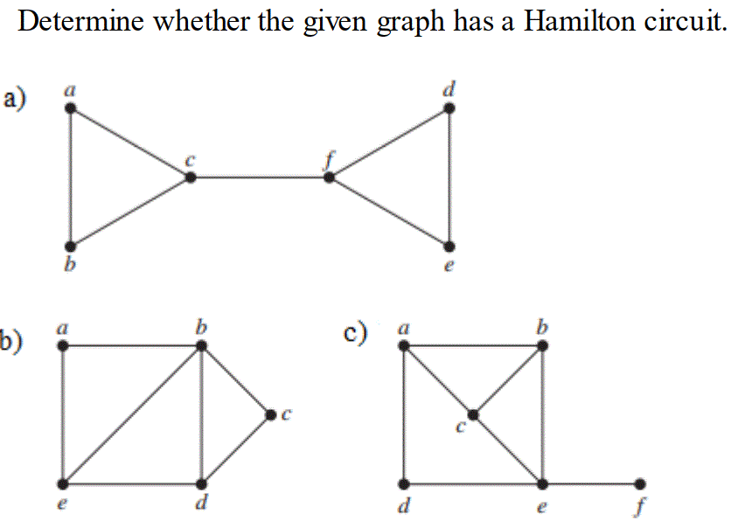
a. | b) only
b. | a) only
c. | b) and c)
d. | None of the others
e.
ANSWER: | A
MARK: | 1
UNIT: | 1
LO: | 0
MIX CHOICES: | Yes

QN=32 | [file: t32.gif]  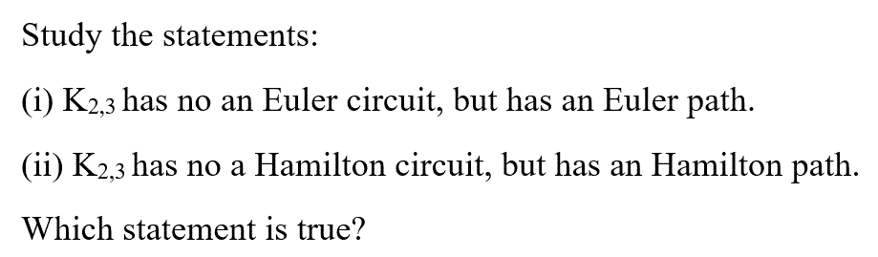
a. | Both (i) and (ii)
b. | (i) only
c. | (ii) only
d. | None of the others
e.
ANSWER: | A
MARK: | 1
UNIT: | 1
LO: | 0
MIX CHOICES: | Yes

QN=33 | [file: t33.gif]  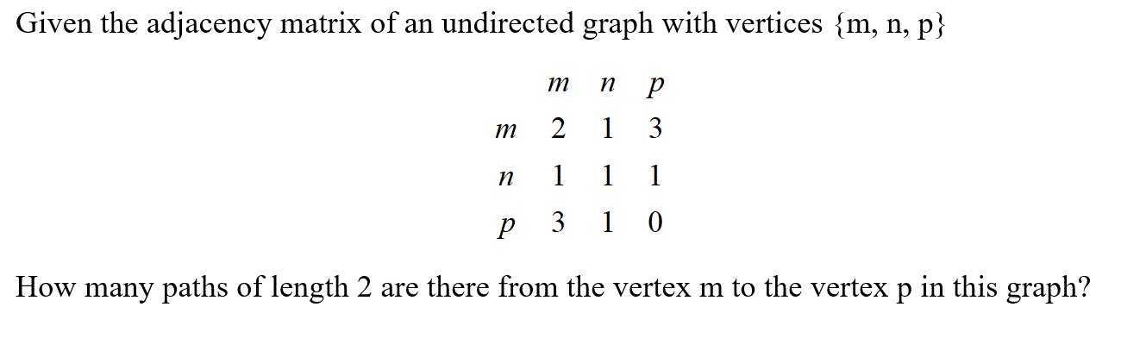
a. | 7
b. | 6
c. | 14
d. | 10
e. | None of the others
ANSWER: | A
MARK: | 1
UNIT: | 1
LO: | 0
MIX CHOICES: | Yes

QN=34 | Use Huffman coding algorithm to encode the word "football".  What is the average number of bits required to encode a character?
a. | 2.5
b. | 2.25
c. | 2.45
d. | 2
e.
ANSWER: | A
MARK: | 1
UNIT: | 1
LO: | 0
MIX CHOICES: | Yes

QN=35 | Which codes are prefix codes?  (i) a: 101, b: 010, c: 1101, d: 110  (ii) a: 110, b: 101, c: 1110, d: 1001
a. | (ii) only
b. | (i) only
c. | Both (i) and (ii)
d. | None of the others
e.
ANSWER: | A
MARK: | 1
UNIT: | 1
LO: | 0
MIX CHOICES: | Yes

QN=36 | Study the following prefix expression: + - * 2 3 5 / * 2 3 3  It will be evaluated to ….
a. | 3
b. | 2
c. | 4
d. | 6
e. | None of the others
ANSWER: | A
MARK: | 1
UNIT: | 1
LO: | 0
MIX CHOICES: | Yes

QN=37 | Given the coding scheme: a: 00, b: 01, c: 10, d: 110, e: 111.  Find the word represented by: 1100001
a. | dab
b. | abc
c. | eab
d. | cab
e.
ANSWER: | A
MARK: | 1
UNIT: | 1
LO: | 0
MIX CHOICES: | Yes

QN=38 | Which of the following is false in the case of a spanning tree of a graph G?
a. | It can be cyclic
b. | It is a subgraph of the G
c. | It includes every vertex of the G
d. | It is tree that spans G
e.
ANSWER: | A
MARK: | 1
UNIT: | 1
LO: | 0
MIX CHOICES: | Yes

QN=39 | How many edges must be removed from a connected graph with 8 vertices and 12 edges to produce a spanning tree?
a. | 5
b. | 6
c. | 7
d. | 4
e.
ANSWER: | A
MARK: | 1
UNIT: | 1
LO: | 0
MIX CHOICES: | Yes

QN=40 | A full 5-ary tree with 45 leaves has ____ internal vertices
a. | 11
b. | 12
c. | 13
d. | 14
e.
ANSWER: | A
MARK: | 1
UNIT: | 1
LO: | 0
MIX CHOICES: | Yes

QN=41 | Construct a binary search tree for the numbers: 5, 3, 6, 2, 4, 7. How many comparisons are used to locate the number “2”?
a. | 3
b. | 2
c. | 4
d. | 5
e.
ANSWER: | A
MARK: | 1
UNIT: | 1
LO: | 0
MIX CHOICES: | Yes

QN=42 | Find the value of the expression 5 4 + 6 3 / 7 - *
a. | 9
b. | -9
c. | -7.5
d. | -45
e. | None of the others
ANSWER: | D
MARK: | 1
UNIT: | 1
LO: | 0
MIX CHOICES: | Yes

QN=43 | A full binary tree with 12 internal vertices has ____ edges.
a. | 24
b. | 13
c. | 12
d. | 25
e.
ANSWER: | A
MARK: | 1
UNIT: | 1
LO: | 0
MIX CHOICES: | Yes

QN=44 | [file: t44.gif]  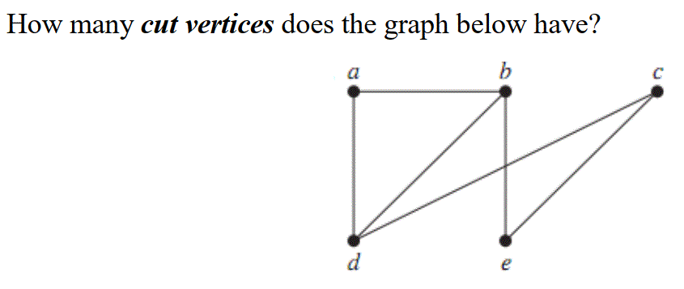
a. | 0
b. | 1
c. | 2
d. | 3
e.
ANSWER: | A
MARK: | 1
UNIT: | 1
LO: | 0
MIX CHOICES: | Yes

QN=45 | [file: t45.gif]  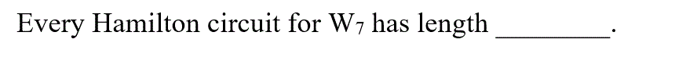
a. | 8
b. | 7
c. | 16
d. | The graph has no a Hamilton circuit
e.
ANSWER: | A
MARK: | 1
UNIT: | 1
LO: | 0
MIX CHOICES: | Yes

QN=46 | [file: t46.gif]
a. | 12
b. | 13
c. | 5
d. | 6
e.
ANSWER: | A
MARK: | 1
UNIT: | 1
LO: | 0
MIX CHOICES: | Yes

QN=47 | Which of the following integers are congruent to -15 modulo 9?
a. | 21
b. | 4
c. | -21
d. | -3
e. | None of the others
ANSWER: | A
MARK: | 1
UNIT: | 1
LO: | 0
MIX CHOICES: | Yes

QN=48 | Find the base 7 expansion of 186
a. | 354
b. | 331
c. | 413
d. | 345
e.
ANSWER: | A
MARK: | 1
UNIT: | 1
LO: | 0
MIX CHOICES: | Yes

QN=49 | If a, b are positive integers such that gcd(a, b) = 10 and ab = 70, find lcm(a, b)
a. | 7
b. | 60
c. | 80
d. | None of the others
e.
ANSWER: | A
MARK: | 1
UNIT: | 1
LO: | 0
MIX CHOICES: | Yes

QN=50 | What is the negation of the proposition “If it is not raining then the soccer game will be held”
a. | It is not raining and the soccer game is held
b. | If it is not raining then the soccer game will not be held
c. | If it is raining then the soccer game will not be held
d. | None of the others
e.
ANSWER: | A
MARK: | 1
UNIT: | 1
LO: | 0
MIX CHOICES: | Yes

